**Lab Report: 06**

**Title: Liang-Barsky algorithm for line clipping**

*Course title: Computer Graphics Laboratory*

*Course code: CSE-304*

*3rd Year 1st Semester Examination 2022*

**Date of Submission**: 13/08/2023



**Submitted to-**

**Dr. Mohammad Shorif Uddin**

*Professor*

*Department of Computer Science and Engineering*

*Jahangirnagar University*

*&*

**Dr. Morium Akter**

*Associate Professor*

*Department of Computer Science and Engineering*

*Jahangirnagar University*

*Savar, Dhaka-1342*

| Class Roll | Exam Roll | Name |
| --- | --- | --- |
| 402 |  | Jubaer Ahmad Khan |

**Source Code:**

#include <iostream>

#include <graphics.h>

using namespace std;

const int x_MAX = 300;

const int x_MIN = 50;

const int y_MAX = 500;

const int y_MIN = 250;

bool clipT(double s, double u, double& t1, double& t2)

{

double r;

if (s < 0.0)

{

r = u / s;

if (r > t2)

{

return false;

}

if (r > t1)

{

t1 = r;

}

}

else if (s > 0.0)

{

r = u / s;

if (r < t1)

{

return false;

}

if (r < t2)

{

t2 = r;

}

}

else if (u < 0.0)

{

return false;

}

return true;

}

void liangBarskyClip(double x1, double y1, double x2, double y2)

{

double t1 = 0.0, t2 = 1.0, dx = x2 - x1, dy;

if (clipT(-dx, x1 - x_MIN, t1, t2) && clipT(dx, x_MAX - x1, t1, t2))

{

dy = y2 - y1;

if (clipT(-dy, y1 - y_MIN, t1, t2) &&

clipT(dy, y_MAX - y1, t1, t2))

{

if (t2 < 1.0)

{

x2 = x1 + t2 * dx;

y2 = y1 + t2 * dy;

}

if (t1 > 0.0)

{

x1 = x1 + t1 * dx;

y1 = y1 + t1 * dy;

}

line(x1, y1, x2, y2);

}

}

}

int main()

{

int gd = DETECT, gm;

initgraph(&gd, &gm, "");

initwindow(1000, 1000);

rectangle(x_MIN, y_MIN, x_MAX, y_MAX);

line(0, 300, 150, 550);

line(150, 450, 350, 600);

line(100, 350, 250, 300);

line(250, 100, 350, 350);

line(0, 550, 100, 700);

int fillGd = DETECT, fillGm;

initgraph(&fillGd, &fillGm, " ");

initwindow(1000, 1000);

rectangle(x_MIN, y_MIN, x_MAX, y_MAX);

liangBarskyClip(0, 300, 150, 550);

liangBarskyClip(150, 450, 350, 600);

liangBarskyClip(100, 350, 250, 300);

liangBarskyClip(250, 100, 350, 350);

liangBarskyClip(0, 550, 100, 700);

getch();

closegraph();

closegraph();

return 0;

}

**Output:**

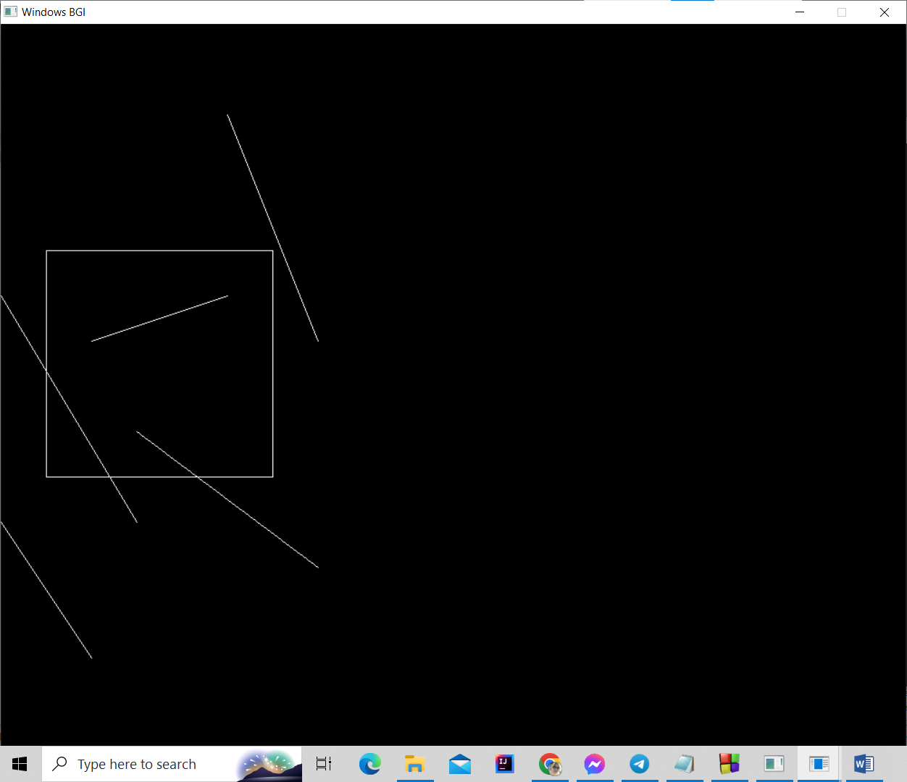

**Fig: The given viewport and lines**

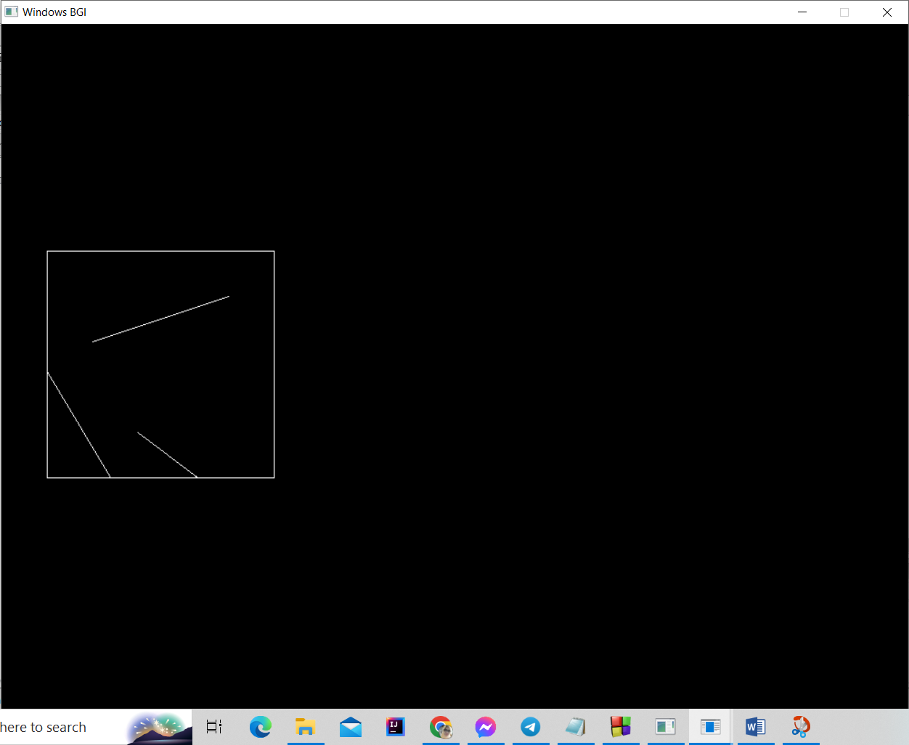

**Fig: Clipped lines**